6D5N YANGON – BAGAN – MT.POPA – MANDALAY – YANGON

DAY 1: YANGON ARRIVAL – CITY SIGHTSEEING ( L, D )
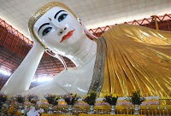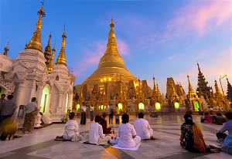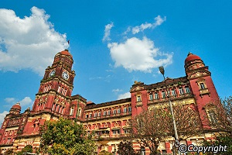
Chauk Htat Gyi pagoda Shwedagon Pagoda Yangon high court building

Arrive at Yangon International Airport. Welcome by our tour guide. Transfer to Hotel. Yangon sightseeing tour includes Chaukhtatgyi, a huge reclining Buddha image, extended visit to SHWEDAGON POGODA, one of the world’s most spectacular religious monuments and the golden dome of Shwedagon Pagoda rises 98meters above its base and is covered with 60 tons of pure gold, will conclude the tour of this picturesque garden city. Overnight at hotel in Yangon.

Meal : 1 Lunch + 1 Dinner
Accommodation: Overnight in Yangon.
The distance: Yangon International Airport – Yangon Capital : 15 km – 40 minutes for transfer.

DAY 2: YANGON – BAGAN SIGHTSEEING ( B/L/D)
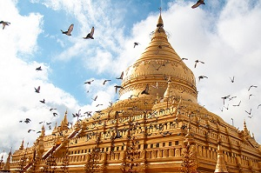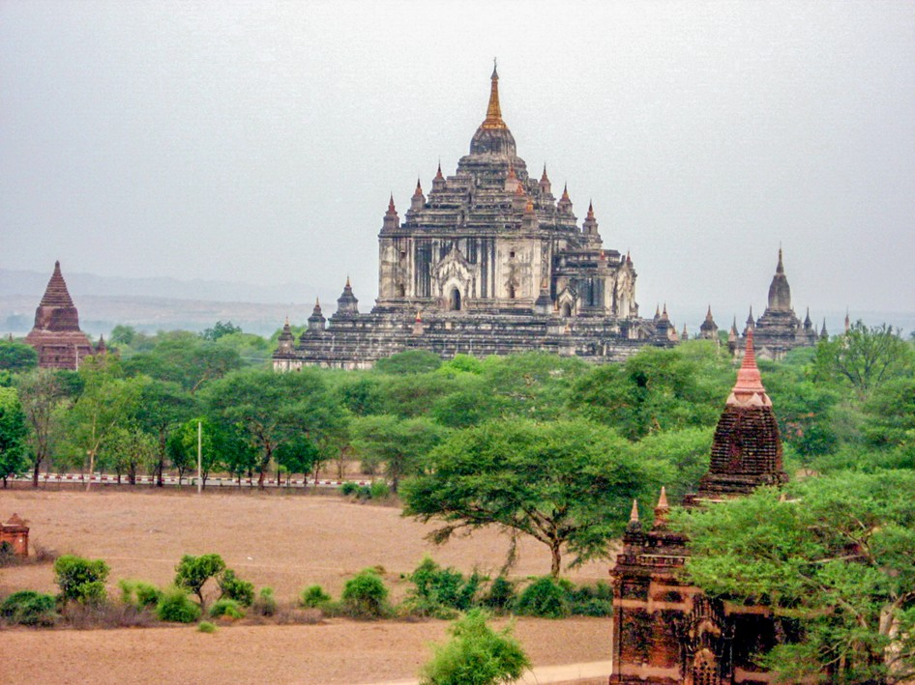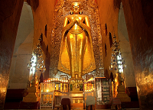
Shwezigon Pagoda Gubyanuk Gyi Ananda Temple

After breakfast, transfer to airport for domestic flight to Bagan. On arrival, transfer to hotel and proceed for sightseeing, starting with the busy local market and continuing with visits to a diverse selection of the most important Pagodas and temples, such as SHWEZIGON PAGODA, built by King Anawrahta in the early 11th century, GUBYANUK GYI, a temple with exquisite murals of Jataka scenes, and ANANDA TEMPLE with four huge standing Buddha images and numerous seated figures in ches around the galleried interior. Continue sightseeing to MANUHA TEMPLE, built in Mon Style in 1095, Nanbaya Temple, a unique sandstone monument, said to have been the palace of King Manuha and Myingaba Gu Byaukgyi Temple, noted for its ancient mural paintings under the protection of UNESCO. Proceed to SHWESANDAW STUPA to watch sunset over the Ayeyarwaddy River. Overnight at hotel in Bagan.

Meals: 1 Breakfast + 1 Lunch + 1 Dinner
Accommodation: Overnight in Bagan
The distance: Nyaung U Airport – Hotel : 8 km – 15 minutes for transfer

DAY 3: BAGAN – MT POPA - BAGAN ( B/L/D)
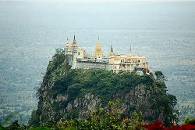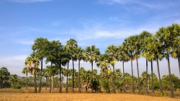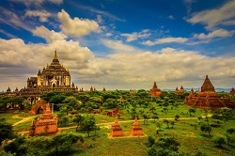
Mt.Popa The palm trees view Bagan View
Excursion to MOUNT POPA about one hour by car, an extinct volcano with its shrines dedicated to animist spirits known as “NATS”. For the energetic, time to climb up the 777 steps to the shrine at the top of the volcanic plug. Drive back to Bagan and study the daily life of the people among the palm trees.
Overnight at hotel in Bagan.

Meals: 1 Breasfast + 1 Lunch + 1 Dinner
Accommodation: Hotel in Bagan
The distance: Bagan – Mt Popa : 50 km – 1hour & 15 minutes for transfer

DAY 4: BAGAN – MANDALAY – AMARAPURA – CITY SIGHTSEEING ( B/L/D)
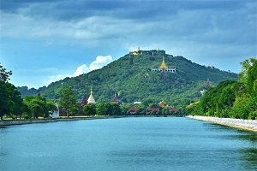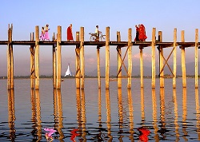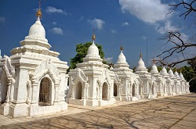
Mandalay Hill U Bein Teak Wood bridge Kuthodaw Pogoda
After breakfast, transfer to airport for domestic flight to Mandalay. Drive to Amarapura. Visit about 200 years old U BEIN'S TEAK WOOD BRIDGE. Then proceed to MAHAGANDARYON MONASTERY where there are more than 1500 Buddhist monks. Then proceed to MAHAMUNI PAGODA with its spectacular Buddha image covered with thick layers of gold leaves, Gold-leaf beating, SHWE NAN DAW KYAUNG or GOLDEN PALACE MONASTERY, a superb example of a traditional wooden building and KUTHODAW PAGODA, known as the world's biggest book, consisting of 729 marble slabs engraved with Buddhist scriptures. Among the historical buildings craftsmen’s workshop like Bronze casting, Marble stone carving, Kalaga tapestries, should be seen. Sunset from MANDALAY HILL.Overnight at hotel in Mandalay

Meals: 1 Breakfast + 1 Lunch + 1 Dinner
Accommodation: Hotel in Mandalay
The distance: Mandalay Intetnational Airpot – Hotel: 35 km – 50 mins for transfer

DAY 5: MANDALAY - MINGUN SIGHTSEEING - YANGON (B/L/D/)
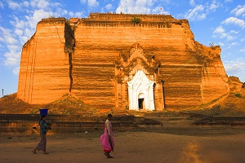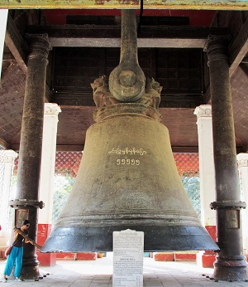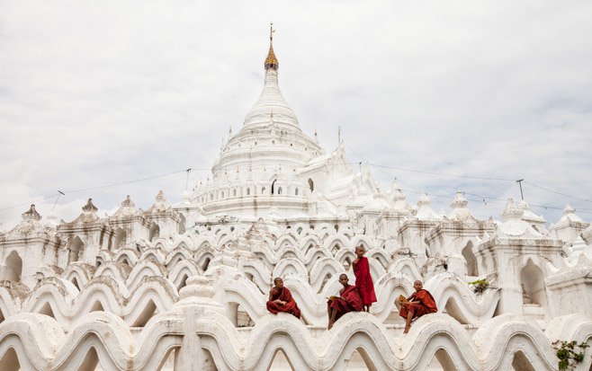
PATHODAWGYI PAYA MINGUN BELL MYATHEINDAN ZEDI

Boat trip on the Ayayyarwaddy River to MINGUN about 11km (1hour) upriver from Mandalay with visits to the the

PATHODAWGYI PAYA, built as one of the world’s largest chedis by King Bodaw Paya. MINGUN BELL, weighing 90 tons and being the largest uncracked bell in the world, to MYATHEINDAN ZEDI. After sightseeing, fly back to Yangon. Arrive Yangon, transfer to the hotel. Overnight at hotel in Yangon.

Meals: 1 Breakfast + 1 Lunch + 1 Dinner
Accommodation: Hotel in Yangon
The distance: Hotel in Mandalay – Mingun: 30 km – 1hour & 20 minutes for transfer
Mandalay city – Mandalay city airport: 35 km – 50 mins for transfer
Yangon airport – hotel in Yangon city: 15 km – 40 minutes for transfer.

DAY 6 : YANGON SHOPPING - DEPARTURE (B/-/-)
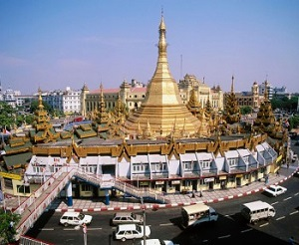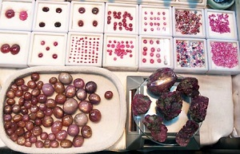
City Hall Building Sule pagoda Ruby shop

This morning you visit the old colonial style city center with the gilded SULE POGODA, dating back over 2,000 years., BOGYOKE (SCOTTS) MARKET with hundreds of stores and of a gems shops. Then transfer to airport for your departure flight.
Meals: 1 Breakfast
The distance: Hotel – Yangon International Airport : 15 km – 40 minutes for transfer.

The ends of program!

SEQUENCE OF ITINERARY SUBJECT TO LOCAL ARRANGEMENT

PRICE INCLUDE:
- Accommodation – as hotel in the list or similar – based on Twin/Double/Triple sharing
- Tour guide: English speaking guide during the tour.
- Boat trips mentioned
- Shows and sightseeing in schedule.
- Transportation by private air-conditioner.
- 01 bottle ( 500 ml )of drinking water for each pax per day.
- Meals (Burmese Food & Chinese Food) as the tour code ( B: Breakfast, L: lunch, D: Dinner)
- Domestic flights
PRICE EXCLUDE:
- International flight ticket & airport tax (if have)
- Camera fee
- Personal expenses: Tel, Fax, Mini Bar, Laundry,etc.
- Personal travel insurance
- Compulsory Tip for local guide and driver (USD/PAX/DAY)

Group Size | Tips in USD
2 – 4pax | 6
5-7pax | 5
8 - up | 3

- Surcharge with other languages guide.
- Surcharge at hotel case by case
  - Burmese New Year (TBA)
  - Gala Dinner on X’Mas (24, 25 Dec ) & New Year 31 Dec

Hotel listed or Similar |  |  | All rates are next in USD/pax  valid for LOW SEASON from 01 May 19 to 30 Sep 2020
 |  |  | Tour by private car / bus with private guide
YANGON | BAGAN | MANDALAY | 2 | 3-4 | 5-6 | 7-9 | 10-12 | 13-15 | 15+1 | 20+1 | 25 +1 | 30+1 | SGL SUP
Grand United Ahlone  Grand United China Town 3*  Grand United donwntown -21st str 3* | Yadanarbon Bagan 3*  The Regency 3* | Hotel Mandalay 3*  Mandalay City 3*  Yadanarbon Dynasty 3*  Or Similar | 915 | 795 | 725 | 690 | 670 | 650 | 650 | 635 | 625 | 615 | 75
Taw Win Garden 4* | Amazing Bagan 4*  Treasure 4*  Thiripyitysaya Sanctuary 4* | Hazel 4* | 970 | 850 | 780 | 740 | 720 | 700 | 700 | 685 | 675 | 665 | 180
Park Royal 5*  Chatrium 5* | Bagan Lodge 5*  Aureum Palace 5* | Mandalay Hill 5* | 1135 | 1040 | 955 | 955 | 900 | 875 | 875 | 865 | 855 | 840 | 295

Hotel listed or Similar |  |  | All rates are next in USD/pax  valid for HIGH SEASON from 01 Oct 18 to 10 Apr 19
 |  |  | Tour by private car / bus with private guide
YANGON | BAGAN | Mandalay | 2 | 3-4 | 5-6 | 7-9 | 10-12 | 13-15 | 15+1 | 20+1 | 25 +1 | 30+1 | SGL SUP
Grand United Ahlone  Grand United China Town 3*  Grand United donwntown -21st str 3* | Yadanarbon Bagan 3*  The Regency 3* | Hotel Mandalay 3*  Mandalay City 3*  Yadanarbon Dynasty 3*  Or Similar | 955 | 835 | 765 | 725 | 705 | 690 | 685 | 670 | 660 | 650 | 165
Taw Win Garden 4* | Amazing Bagan 4*  Treasure 4*  Thiripyitysaya Sanctuary 4* | Hazel 4* | 1010 | 890 | 820 | 785 | 765 | 745 | 745 | 730 | 720 | 710 | 225
Park Royal 5*  Chatrium 5* | Bagan Lodge 5*  Aureum Palace 5* | Mandalay Hill 5* | 1225 | 1105 | 1035 | 1000 | 980 | 960 | 965 | 945 | 935 | 925 | 440

NOTE

The timing of sightseeing points shall be fixing by local operator due to traffic and weather conditions, however all points must cover unless amendment or cancellation make by clients themselves (Non-refundable for any cancellation that made by clients)

Tour and price are subject to change without notice or incase of deduct number of pax in quoted group.

Small deviations in the tour program are sometimes necessary, depending on weather, road conditions, flight schedules and room availability.

Supplement charge for room rate in peak dates depends on the hotel category used. Compulsory gala dinner on X’mas, New Year’s Eve & Water Festival to be advised upon booking. Prices for group of 15 persons up in 5 stars hotels sometime requires to re-quote bases on the hotel policy

Group tour 20pax, you will get 01 FOC for tour leader based on twin sharing basis include breakfast (domestic air ticket is not applicable)

BUS

Group Size | Kind of Transportation
1-2 pax | 4 seater
3 pax | 7 seater
4-9pax | 16 seater
10-18 pax | 30 seater
19-21 pax | 35 seater
22 – 42 pax | 45 seater

CHILD POLICY

- Infant below 2 years old sharing same room with parents is free of charge.
- Child below 12 yrs old sharing same room with 1 ADL is charged for 90%.
- Child below 12 yrs old with extra bed and sharing same room with parents is charged for 65%.
- Child below 12 yrs old No extra bed & sharing same room with parents is charged for 55%.

TERM & CONDITIONS

1. CANCELLATION
In case of cancellation, fees will be charged accordingly to the day that official notice in writing is received at Hanoi Office: No 11, lane 8, Doi nhan, Ba Dinh district, Hanoi-Vietnam.
- Before 30 days: No charge
- Less than 30 days: 50% of total tour price
- Less than 14 days: 75% of total tour price
- Less than 7 days before arrival date or no-show: 100% of total tour price

Any cancellation due to irresistible reasons such as wars, strikes, earthquakes, etc. will be considered subject to each case.

